**Help Sheet for Blue Flash Cards**

**Intervals**

An interval is the distance in pitch between two notes. To get the interval from the written music, count the number of lines and spaces (including the starting note). To get the interval based on the piano keys, count the number of keys including the first key to the last key (i.e. a C to a G is a fifth).

Harmonic Intervals

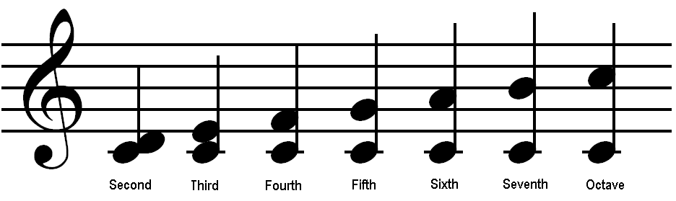

**Key Signatures**

**Order of sharps: Fat Cats Go Down Alleys Eating Bread**

**Order of flats: BEAD GCF**

* **Major Keys**:

C major has no sharps and no flats, F major has one flat (Bb). These two keys are an exception since the formulas below do not work for them.

If the key signature has **sharps**, determine the name of the **last sharp and raise it by a half-step** to get the key. For example, if the last sharp is E sharp, raise it a half step which is F sharp, the key is F sharp major.

When the key signature has **flats (b)**, simply look at the **next to the last flat** and that is what key you are in. So for example, if you have 3 flats (Bb, Eb, Ab) you are in the key of Eb.

* **Minor Keys:**

Simply find the **name of the key in the major key and lower it four half steps** to get the minor key. For example E flat major lowered four half steps will be C minor. A minor key that has the same key signature as a major key is called a **relative minor**. For example E flat major and C minor both have 3 flats but C minor is four half steps lower than E flat major.